Agent Architecture Diagram
Project: SME Procurement-Preparation Agent — CACv Supermarket, Kyanja
Prepared by: Martina (AI Engineering Lead) — Group D — Week 5

Task This Architecture Supports
Weekly Reorder Preparation: the agent checks inventory, identifies items below their reorder threshold, compares supplier quotes for each flagged item, and drafts a purchase requisition per item — stopping once every flagged item has a draft (or a limit/error is hit) and handing off to a human for approval. This is a genuinely multi-step task: the number of loop iterations depends on how many items need reordering, which is not known in advance.
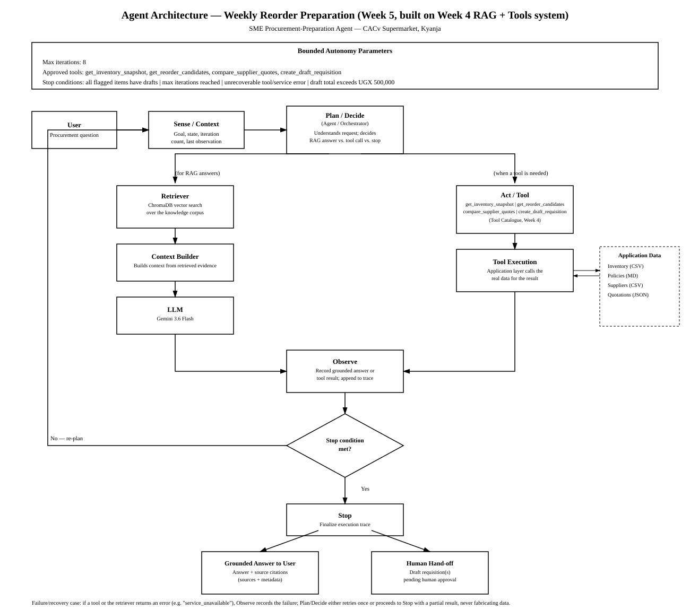
How This Builds on the Week 4 RAG + Tools Architecture
This diagram does not replace the Week 4 RAG architecture (Retriever/ChromaDB → Context Builder → LLM) or the Week 4 Tool Catalogue — it wraps both inside the bounded agent loop the course requires this week. The Agent/Orchestrator from Week 4 is now explicitly the Plan/Decide step: on each iteration it decides whether to answer via RAG, call a tool, or stop, rather than handling only a single request-response pass.
Loop Description
- Sense/Context: the agent reads the current goal, state so far, iteration count, and the last observation.
- Plan/Decide (Agent/Orchestrator): decides whether this step needs a RAG-grounded answer, a tool call, or whether the task is complete.
- RAG path: Retriever (ChromaDB vector search) → Context Builder → LLM (Gemini 3.6 Flash), used when the step needs a grounded answer from the knowledge corpus.
- Tool path: Act/Tool calls one of the four approved tools (see Tool Catalogue and Schemas, Week 4) via Tool Execution, which reads the real Application Data (inventory, policies, suppliers, quotations).
- Observe: whichever path ran, its result (grounded answer or tool result) is recorded and appended to the execution trace.
- Stop condition check: the loop re-plans (returns to Plan/Decide) if not finished, or proceeds to Stop if a stop condition is met.
- Stop → two possible outcomes: a Grounded Answer is returned to the user with source citations, and/or any draft requisition(s) produced are handed to the SME owner as pending human approval — the agent itself never finalizes a purchase.
Bounded Autonomy Parameters
Max iterations: 8 — bounds total tool calls per run, preventing runaway loops.
Approved tools: get_inventory_snapshot, get_reorder_candidates, compare_supplier_quotes, create_draft_requisition — the agent cannot call anything outside this set.
Stop conditions: all flagged items have a draft requisition; max iterations reached; a tool returns an unrecoverable error; or the running draft total exceeds UGX 500,000 (the procurement policy's sign-off threshold, which forces a stop and human review rather than letting the agent keep drafting).
Failure / Recovery Case
If a tool call returns a “service_unavailable” error, Observe records the failure in the trace. Plan/Decide then either retries the same tool once, or proceeds to Stop with whatever partial result has been gathered so far — the agent never fabricates data to fill the gap, consistent with the failure behaviour defined for each tool in the Week 4 Tool Catalogue.

